CaseManagement_CreationOfCase_Instance23_03-Aug-2018_08-09-46_AM_SingleSignOn.png

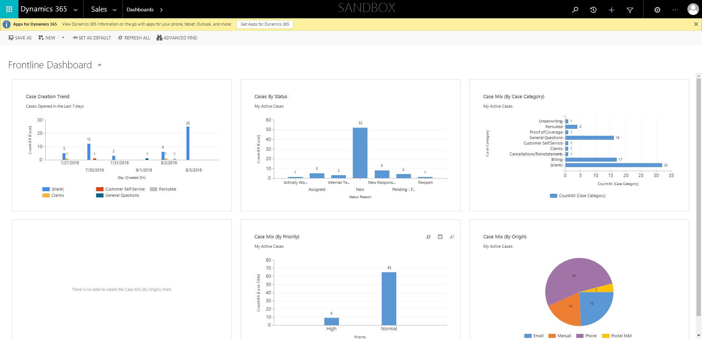

CaseManagement_CreationOfCase_Instance23_03-Aug-2018_08-09-44_AM_SingleSignOn.png

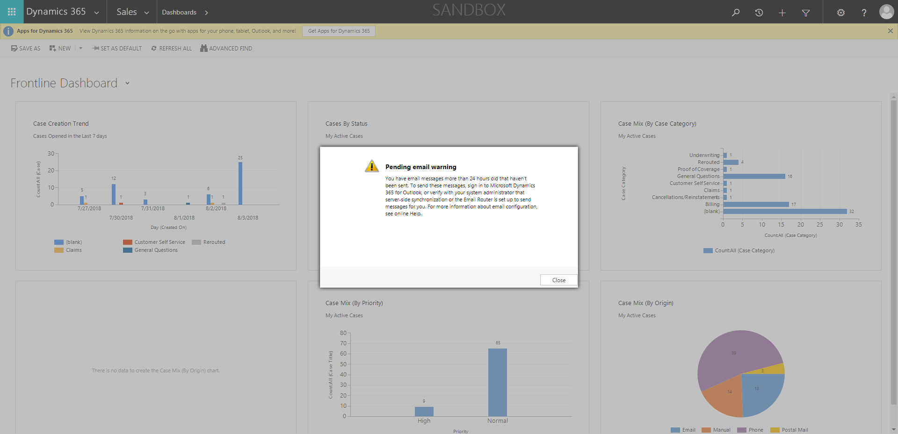

CaseManagement_CreationOfCase_Instance23_03-Aug-2018_08-09-52_AM_MouseClickActionMoveToElementBycssSelectoranavcases.png

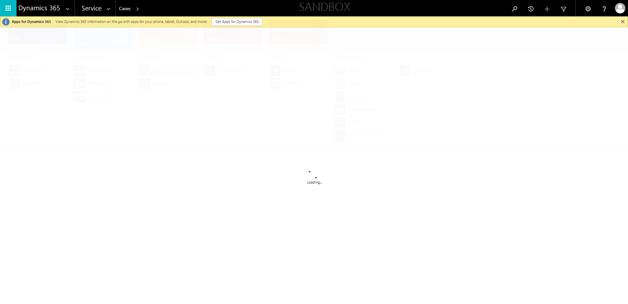

CaseManagement_CreationOfCase_Instance23_03-Aug-2018_08-09-21_AM_MouseClickActiononStaleElement.png

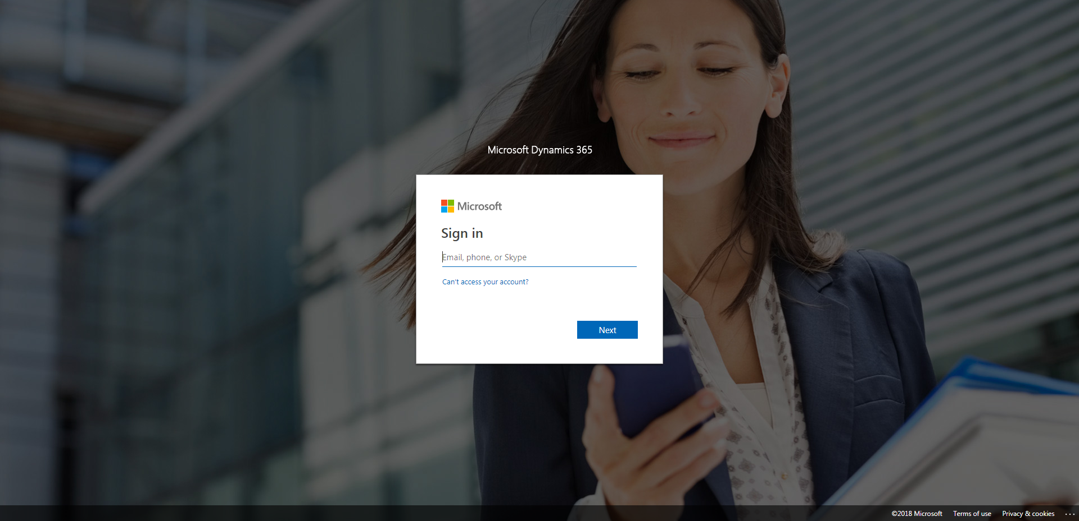

CaseManagement_CreationOfCase_Instance23_03-Aug-2018_08-09-23_AM_EnterTextAction.png

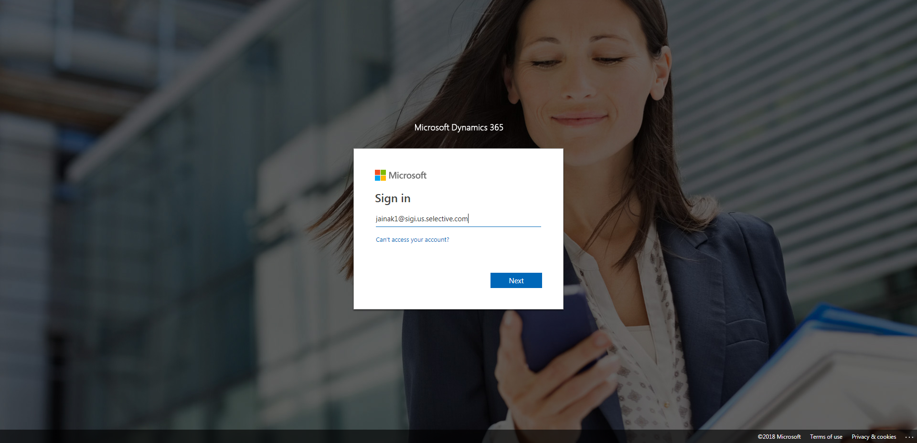

CaseManagement_CreationOfCase_Instance23_03-Aug-2018_08-09-50_AM_MouseClickActionMoveToElementBycssSelectorspanTabSFA.png

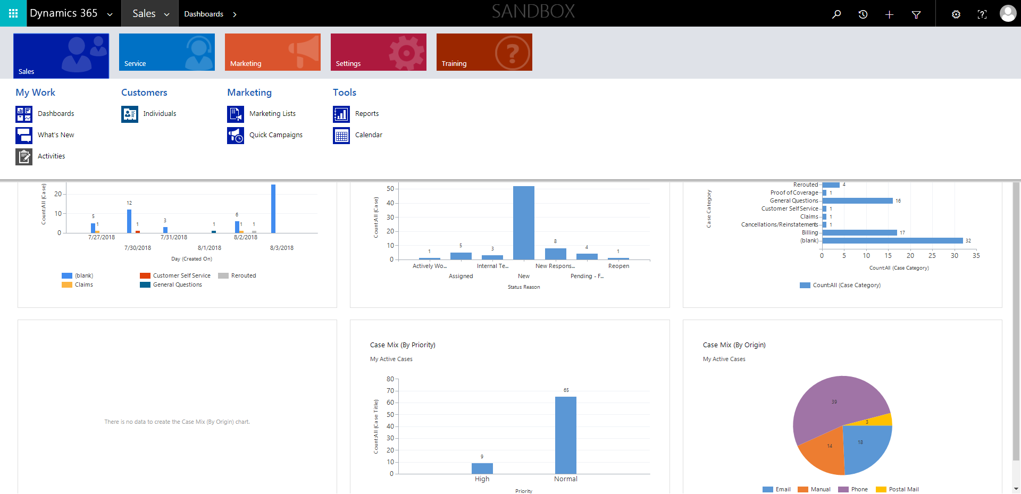

CaseManagement_CreationOfCase_Instance23_03-Aug-2018_08-09-24_AM_MouseClickActiononStaleElement.png

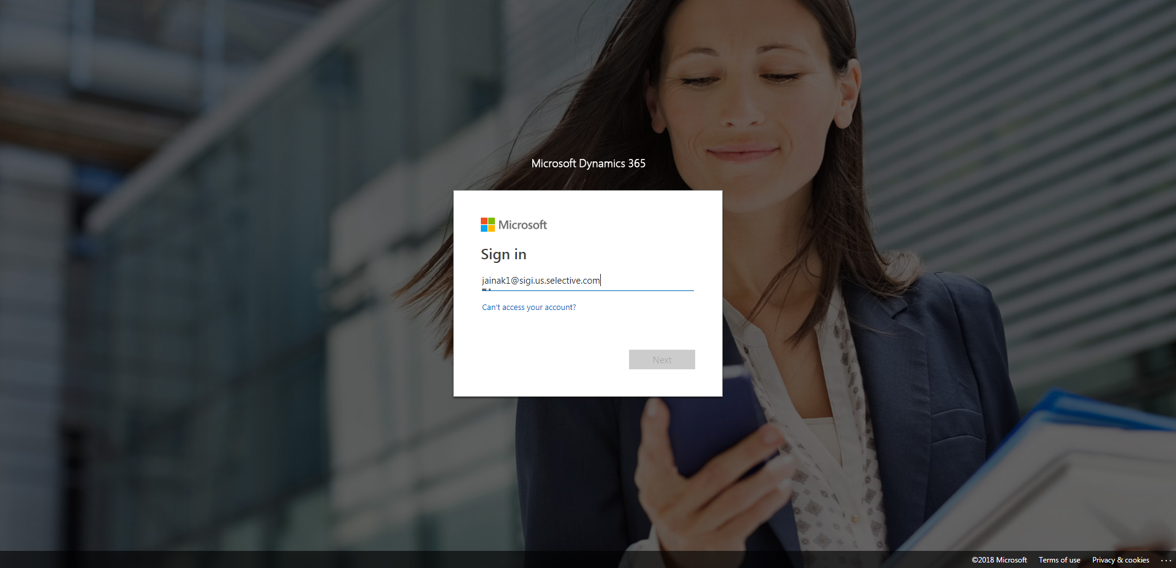

CaseManagement_CreationOfCase_Instance23_03-Aug-2018_08-09-51_AM_MouseClickActionMoveToElementByxpathimgaltServiceparentspan.png

